LMH 521 Final Assignment

Step 1 – Error/Near Miss
A few months ago, I had the opportunity to round on a patient admitted for volume overload due to heart failure. The patient was placed on a diet with fluid restrictions and was given Lasix to assist with diuresis. However, the patient also had a history of hypotension, and the provider responsible for this patient forgot to place ‘hold’ parameters to stop administering Lasix if their blood pressure dropped below a certain threshold. As a result, the patient’s blood pressure dropped too low on several occasions, which lead to the patient experiencing several episodes of symptomatic hypotension. On one occasion, IV fluids were needed to correct the patient’s blood pressure and return it to an acceptable baseline even though the purpose of hospitalizing this patient was to remove excess fluid. Without blood pressure ‘hold’ parameters in place, the patient was at an increased risk of over-diuresis to the point where they became hypotensive. Each one of these hypotensive episodes subsequentially put the patient at an increased risk for shock. Additionally, the use of IV fluids to correct these episodes added unnecessary costs to the patient’s total hospital bill, without improving outcomes. Understandably, the patient was quite frustrated with the quality of their care while hospitalized.

Step 2 – Opportunity Statement
Configure EPIC to require blood pressure ‘hold’ parameters before diuretics can be prescribed to reduce instances of diuretic-induced hypotensive episodes that place patients at an increased risk of shock and unnecessary financial costs.

Step 3 – Aims Statement
In 3 months, I will reduce the monthly incidence of symptomatic diuretic-induced hypotension by 50% in patients hospitalized for volume overload due to heart failure.

Step 4 – Measures
Outcome Measures – Monthly percentage of patients hospitalized for volume overload due to heart failure that experienced at least one episode of symptomatic hypotension following diuretic administration.

Balancing Measures - Average duration of hospital admission.

Step 5 – Developing Changes
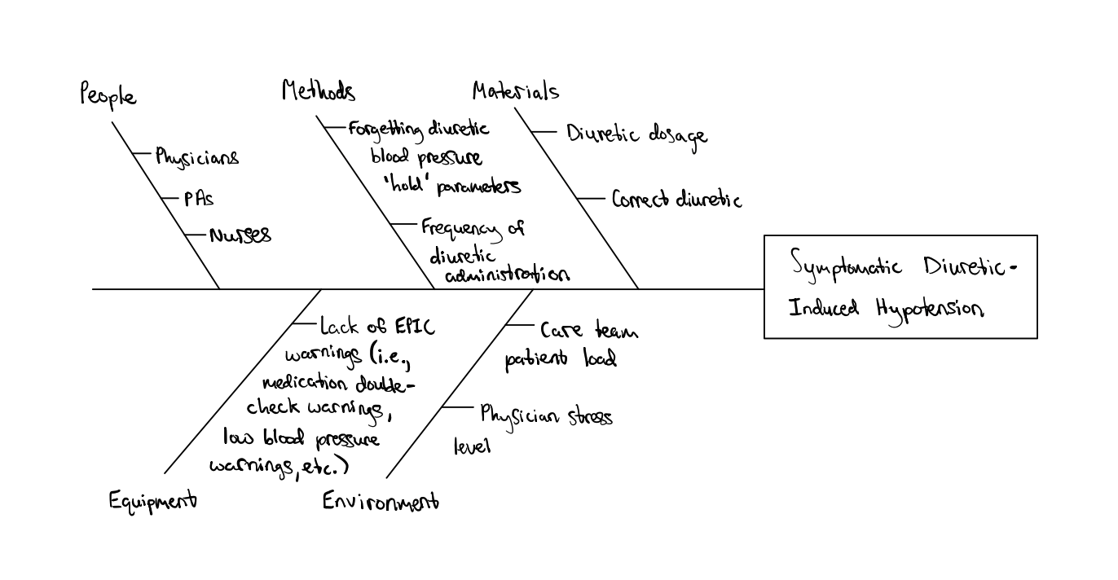

Step 6 – Testing Changes
Plan:
- Question:
  - Will adding blood pressure ‘hold’ parameters to inpatient diuretic prescriptions reduce the monthly incidence of symptomatic hypotensive episodes in patients hospitalized for volume overload due to heart failure.
- Prediction:
  - By adding blood pressure ‘hold’ parameters to inpatient diuretic prescriptions, the monthly incidence of symptomatic hypotension will decrease by at least 50%.
- Plan:
  - Who:
    - A member of IT or EPIC support will add a notification/reminder pop-up requiring that blood pressure ‘hold’ parameters be entered before an inpatient diuretic prescription is placed. Medical staff prescribing diuretics (i.e., physicians, PAs, etc.) will set the blood pressure ‘hold’ parameter to 90/60 mmHg for each diuretic prescription. The MRN of all patients hospitalized for volume overload due to heart failure will be added to a database by the registered nurse monitoring the patient. A research coordinator will be hired to track all patients on the database and collect and analyze relevant data.
  - What:
    - Any time diuretics are prescribed for patients hospitalized with volume overload due to heart failure, blood pressure ‘hold’ parameters will be entered at 90/60 mmHg. A notification will appear on EPIC preventing placement of the order until these parameters are set. Any time diuretics are administered by support staff, the patient’s blood pressure will be verified beforehand. If the patient’s blood pressure is less than 90/60 mmHg, diuretics will not be given until it returns to a level greater than that threshold. Additionally, if the patient’s blood pressure is less than 90/60 mmHg, the patient will be screened for symptoms of hypotension, and all relevant information will be documented in the database for the research coordinator to analyze at a later date.
  - Where:
    - Data will be collected at a single site under *** Health Services.
  - When:
    - Data collection will begin on January 1st, 2023, and end on March 31st, 2023.
- Plan for collecting data:
  - The research coordinator mentioned above will collect the following data:
    - Number of patients hospitalized for volume overload due to heart failure.
    - Number of those patients above that were prescribed diuretics during their hospitalization.
    - Number of patients that experienced at least one episode of symptomatic hypotension, defined as blood pressure < 90/60 mmHg with at least one of the following symptoms: dizziness, confusion, blurry vision, lightheadedness, syncope, nausea, or vomiting.
  - At the end of the study period, all data collected will be analyzed to obtain the monthly incidence of symptomatic hypotension following inpatient diuretic administration. This monthly incidence will then be compared to existing data.

Do:
- EPIC support staff implemented the notification requiring that blood pressure ‘hold’ parameters be entered before inpatient diuretics could be prescribed. The test officially began on January 1st, 2023. For the first two weeks, there were several issues that had to be resolved. Of the 6 hospitalists and 3 PAs on rotation at this hospital, 2 of the physicians had trouble with the notification appearing automatically. As a result, those 2 providers forgot to place blood pressure ‘hold’ parameters on 5 different patients over a 2-week time-period. 2 of those patients became symptomatically hypotensive at least once due to excessive diuresis, and 1 patient required resuscitation with additional IV fluids to correct their blood pressure. After these first two weeks, EPIC support corrected the notification feature, and blood pressure ‘hold’ parameters were placed for every patient given diuretics for the duration of the study. The test was run for the next couple of months before concluding on March 31st. At the end of this three-month period, 211 patients were hospitalized for volume overload due to heart failure. Of those patients, 195 were prescribed diuretics during their hospitalization. 42 of those 195 patients given diuretics experienced at least one episode of symptomatic hypotension (<90/60 mmHg). 12 of those 42 patients required additional measures to correct their blood pressure and alleviate their symptoms. At the end of the study time-period, 14 of the 21 registered nurses self-reported that they forgot to add a patient MRN to the database or failed to report an episode of symptomatic hypotension on at least one occasion.

Study:
- Prediction:
  - By adding blood pressure ‘hold’ parameters to inpatient diuretic prescriptions, the monthly incidence of symptomatic hypotension will decrease by 50%.
- Results:
  - After analyzing all the data collected in this three-month test trial, the average monthly incidence of symptomatic hypotension following diuretic administration was 21.5%. The average monthly incidence for the year 2022 was 45%. Therefore, this test demonstrated a 52.2% reduction in the monthly incidence of symptomatic hypotension following diuretic administration, which exceeds our initial goal of a 50% reduction.
  - Our results showed a significant reduction in the number of patients that experienced at least one episode of symptomatic hypotension when blood pressure ‘hold’ parameters were required prior to placing prescription orders. This of course benefits patients by ensuring that higher quality care and comfort are given while administering treatment. Reducing the number of hypotensive episodes also decreases the chance that patients may require corrective medications or fluids, which decreases the financial burden on patients. However, it is important to recognize that an unknown number of patients and instances of symptomatic hypotension were lost to analysis during this test due to providers failing to document appropriately in the database. It is hypothesized that the busy workloads and lack of automatic electronic reminders to document contributed to this error. Likewise, it is unknown how much this error may skew our results. Therefore, to avoid this error in the future, I would like to implement additional notifications and reminders in EPIC prompting healthcare providers to remember to document appropriately in the database so that all patients with heart failure and all instances of symptomatic hypotension are accounted for.

Act:
- Our initial test results suggest that we should adopt the use of required blood pressure ‘hold’ parameters any time diuretics are prescribed to hospitalized patients. However, some modifications will need to be made to further optimize this new system. As mentioned briefly above, we will need to recruit EPIC support to modify the system so that automatic reminders appear on a frequent basis reminding staff to update the database. The purpose of this will be to ensure that all patients hospitalized for volume overload due to heart failure are accounted for, as well as the number of symptomatic hypotensive episodes. The hospital is a busy, stressful environment, and automatic reminders on EPIC will reduce the chance that care providers will simply forget to update the database. In doing so, more patients will be included in the final data analysis which will offer more accurate results. Once EPIC support staff has implemented it, we will reconduct this study for one more three-month time-period to determine the monthly incidence of symptomatic hypotension once again. If the results of this second trial are consistent with the results of our first test, we will proceed with fully adopting this system into clinical practice.

