LMH 521 Final Assignment
Step 1: One issue persistent across many clinics I saw was long patient wait times for scheduled appointments. This issue was particularly severe on one day when a particular clinic was running three hours late for patient appointments. While some amount of wait is usually expected in many medical offices (15-30 minutes), running several hours late is not only disrespectful to patients, but can result in poor quality care from rushing or having patients leave before care can be delivered. It also has a negative impact on providers and staff. This also has a disproportionate effect on patients who are already part of more vulnerable populations, who may not be able to take extra time off from work to wait or be able to arrange transportation or childcare on another day.
Step 2: I hope to cut down patient wait times to facilitate optimal patient outcomes, decrease the negative impacts on vulnerable populations, and improve provider workflow, as this is a multifaceted problem that impacts many people in the clinic environment.
Step 3: Ninety percent of patients with scheduled appointments will be seen by the provider within 30 minutes of their appointment time by June 1, 2023.
Step 4:
Outcome Measure  (Where are we ultimately trying to go?) | Percent of patients seen within 30 min?  Average and median wait times per patient?
Process Measure  (Are we doing the right things to get there?) | How much time exists to document visits during the day?  How long are visits scheduled for?
Balancing Measure  (Are the changes introducing problems?) | Are providers and staff working overtime or through breaks?  How many patients are being seen each day?
Step 5: Developing changes:
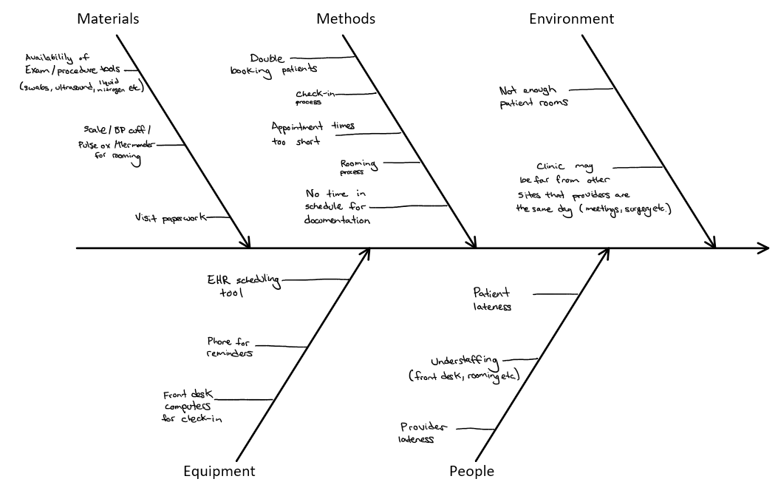
Step 6: Testing changes (Using the PDSA cycle)
Objective: Test a change to patient scheduling, such that patients are not double booked, and there is 30 minutes each in the morning and afternoon blocked off for providers to work on documentation.
Plan: Plan the test, including a plan for collecting data
- Questions and predictions:
  - Will this effectively reduce patient wait times? Patient wait times should be reduced, though the amount saved per patient may still be small.
  - How easy will it be to change the scheduling template for future visits? It may be difficult to change the schedule in the next month where visits are booked out, after that it should be easier to change on blank schedules.
  - How many less patients will be seen? Even though less patients will be scheduled each day, it may be that less patients walk out due to excessive waits, so approximately the same number will be seen.
  - Will the provider have time to document all visits that day? The provider will likely be able to accomplish some of the day’s documentation during the set aside time, but not all of it.
- Who, what, where, when:
  - Starting in two weeks, the front desk staff will implement schedule changes for every Friday for four weeks. Each Friday will be scheduled with 30 minutes of blocked time in the morning and afternoon for provider documentation, as well as blocking double booking of appointments.
- Plan for collecting data:
  - The front desk staff will track the number of minutes each patient spends waiting for the provider in an average week. Then they will track how many minutes were spent waiting on Friday, as well as how many patients were seen each day (both are already built into the EHR). The front desk staff will also write a paragraph about the ease of scheduling changes. The provider will write a paragraph on how their workflow was impacted.
Do: Run the test on a small scale
- Describe what happened. What data did you collect? What observations did you make?
  - On the first Friday, no patients were double booked and two 30 minute blocks set aside for documentation. The front desk staff reported that the technical scheduling change was easy, but they did have patients who wanted to schedule on that day who could not. The provider was able to complete several charts during the documentation time, however they still took 10 minutes after each appointment to work on charts throughout the day, because that was “when the information was fresh”; this delayed appointment starts. The average patient wait time was reduced from 59 minutes to 47 minutes. There were 4 less patients scheduled than on a usual day, with 3 patients leaving due to long wait times. On an average day, 5 patients leave due to long wait times.
Study: Analyze the results and compare them to your predictions
- Summarize and reflect on what you learned:
  - Prediction: Patient wait times should be reduced, though the amount saved per patient may still be small. Result: An average of 12 minutes of wait time was saved per patient.
  - Prediction: It may be difficult to change the schedule in the next month where visits are booked out, after that it should be easier to change on blank schedules. Result: It was easy to change the schedule for only one day two weeks in advance.
  - Prediction: Even though less patients will be scheduled each day, it may be that less patients walk out due to excessive waits, so approximately the same number will be seen. Result: The new schedule resulted in 6 patients less than a full schedule being seen, however only 3 walked out as compared to the usual 5.
  - Prediction: The provider will likely be able to accomplish some of the day’s documentation during the set aside time, but not all of it. Result: The provider did use the 60 minutes total to document, but still used an additional 10 minutes between appointments, still contributing to patients waiting.
Act: Based on what you learned from the test, make a plan for your next step
- Determine what modifications you should make — adapt, adopt, or abandon:
  - Creating a schedule with more time for documentation, and no double booked appointments did contribute to a reduction in patient wait time, and was relatively smooth to implement. However, it is not sufficient to get to the goal of 30 minutes maximum patient wait time. The provider was taking additional time after every appointment to document “while the information was fresh”, so perhaps an adaptation could test the addition of 10 minute blocks between every appointment instead of two solid 30 minute blocks.

