**LMH 521 Final Assignment**

**Event Description:**

A patient was scheduled for a simple one-hour surgery. She and her wife appeared to be fairly apprehensive about the surgery. The patient was put under general anesthesia. Shortly after the surgeon began working, she discovered that she was missing an essential piece of equipment required to carry out the surgery. The hospital was completely out of this piece of equipment, and it wasn’t due to get in another shipment until the following day. The team was quite frustrated that the surgery had been scheduled despite this inventory issue. A member of the care team called a nearby hospital and they were also out of this piece of equipment. The team member called yet another hospital, and this hospital did have the equipment. An employee of this hospital was able to bring our care team the needed equipment. By the time that the team received the equipment that they needed, the patient had been under general anesthesia for three hours. (The anesthesiologist felt that it was less dangerous to the patient for them to stay under anesthesia than to wake up and then be put back to sleep again.)

Another patient scheduled for a procedure later in the day ended up having to be rescheduled due to the delay. The care team informed me with frustration that this miscommunication between hospital inventory and surgery scheduling has been happening frequently to them.

**Opportunity statement:** I would like at least 95% of scheduled surgeries going forward to have the proper equipment available.

**Aims statement:** By June 1st, 2023, the *** Campus of *** Medical Center will improve alignment of scheduled surgeries with available inventory of surgical supplies. 95% or more of elective surgeries that are scheduled at *** Medical Center after June 1st, 2023 will have all of the supplies that are expected to be utilized during the procedure readily available for the care team.

**Outcome measure:** Percent of elective surgeries carried out at the *** Campus of *** Medical Center that have all of the supplies that are expected to be utilized during the procedure readily available for the care team.

**Balancing measure:** Is staff satisfaction decreasing due to increased demands of ensuring that scheduled elective surgeries have all of the necessary supplies? We will measure staff satisfaction for three months before the change is instituted (the average of which will be referred to as the baseline satisfaction rate) and one year after the change is instituted.

**Developing changes:** See fishbone diagram (below).

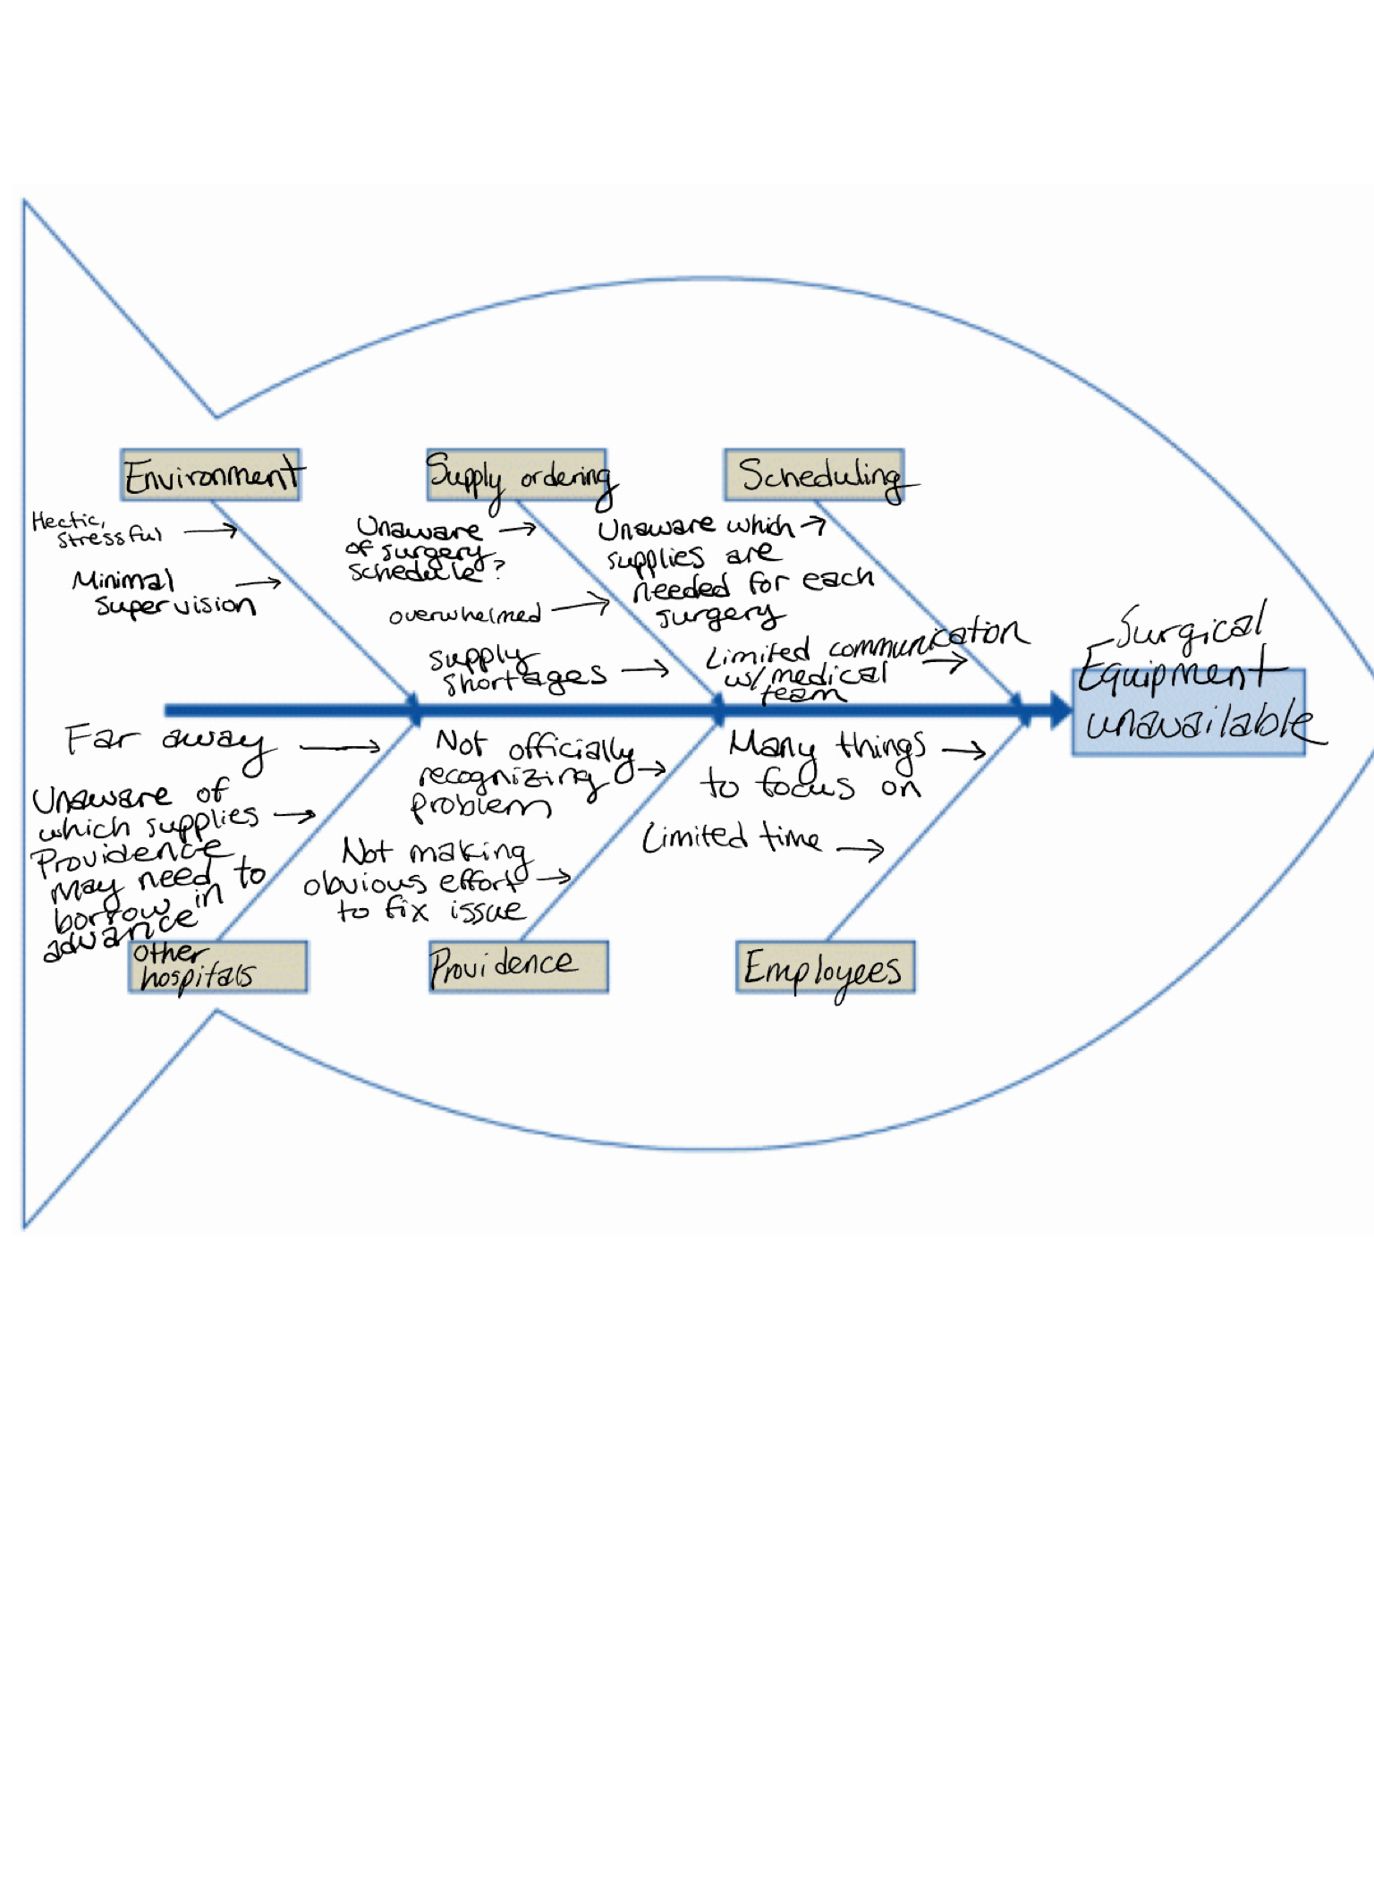

**Testing changes using the PDSA cycle:**

**Objective:** In hopes of improving required equipment availability during surgeries, our objective is to test a system in which surgeons dictate what equipment they anticipate needing for a scheduled surgery to scheduling, scheduling informs supply ordering what equipment will be needed whenever such a surgery is scheduled, and supply ordering takes this information into account when ordering supplies.

* **Plan**
  + Questions and predictions:
    - Question: Will the above strategy (outlined under ‘objective’) improve required equipment availability during surgeries?
      * Prediction: Yes. It will take some time, but eventually this new system of supply ordering will have a higher rate of having the needed supplies ready for each surgery.
    - Question: Will staff satisfaction decrease due to increased demands of ensuring that scheduled elective surgeries have all of the necessary supplies?
      * Prediction: Staff satisfaction will decrease for the first few months. As time goes in and staff grow more comfortable with the new system, staff satisfaction will increase to or rise above its previous level.
  + Who, what, where, when:
    - What:
      * Each surgeon and/or surgical team that operates through Providence will provide to scheduling a list of the equipment that they anticipate requiring for any given surgery that is being scheduled. It may take some time, but eventually scheduling will know what supplies each team needs for the common surgeries that each surgical team performs. Then, surgeons and/or surgical teams will only need to inform scheduling of their equipment list if they are scheduling an unusual procedure or if their equipment list differs for a specific patient. Upon scheduling any given surgery, scheduling will use the equipment list provided and inform supply ordering of what supplies will be required on a given day. Supply ordering will then take this information into account when ordering supplies.
      * Staff satisfaction (including the surgical team, the scheduling team, and the supply ordering team) will be measured on a monthly basis via a 10-point Likert scale.
    - When: Starting on December 1st, 2022.
    - Where: *** Campus of *** Medical Center
    - Who: Surgeons and/or surgical teams, surgical scheduling, and surgical supply ordering
  + Plan for collecting data:
    - Each surgical team will inform the data collection team of each time that supplies that are required for a surgery are unavailable at the time of the scheduled surgery. The data collection team will look at and compare the data each month.
* **Do**
  + Describe what happened. What data did you collect? What observations did you make?
    - Month of December: The number of surgeries without required surgical equipment (hereafter referred to as the number of errors) decreased by 10%. Staff satisfaction decreased 30% from baseline satisfaction rate.
    - Month of January: Number of errors decreased by 30%. Staff satisfaction is 15% below baseline satisfaction rate.
    - Month of February: Number of errors decreased by 50%. Staff satisfaction is 5% below baseline satisfaction rate.
    - Month of March: Number of errors decreased by 70%. Staff satisfaction is 5% above baseline satisfaction rate.
* **Study**
  + Summarize and reflect on what you learned:
    - I predicted that it would take some time, but eventually the new system of supply ordering would have a higher rate of having the needed supplies ready for each surgery.
      * Result: Following the new system, the number of errors decreased by 70% in four months.
    - I also predicted that staff satisfaction would initially decrease but would gradually rise to meet or exceed the baseline satisfaction rate.
      * Result: Following the new system, baseline satisfaction rate initially decreased by 30%. Within four months of instituting the new system, baseline satisfaction rate had risen to 5% above the baseline satisfaction rate.
* **Act**
  + Determine what modifications you should make – adapt, adopt, or abandon:
    - Overall, the new system is working well. However, it has not yet reached the goal threshold of 5% errors or less, so we will continue to monitor the number of errors and make adaptations to the system as seems necessary.
    - As part of this monitoring, we want to take caregiver feedback into account in addition to satisfaction data. Our data collection team wasn’t initially able to do this due to time constraints. In addition to collecting data on the number of errors and staff satisfaction each month, the data collection team will now also request monthly feedback on how the new system is going – whether positive, negative, or neutral, as well as thoughts on how the system could be further improved.